TLS Challenge Report

Overview
The goal of this challenge was to secure a server implementation with TLS by building a CLI tool that generates digital certificates in .pem format. The tool was implemented in Python 3 using the cryptography library, and the certificates were tested with the provided Python server implementation.
Tool: certgen.py
The CLI tool certgen.py generates a self-signed X.509 certificate and an RSA private key, saving them as cert.pem and key.pem inside a certificates/ directory.
Dependencies:
- Python 3
- cryptography library (pip install cryptography)

Example command of execution:
python certgen.py --cn localhost --org "MyOrganization" --country US
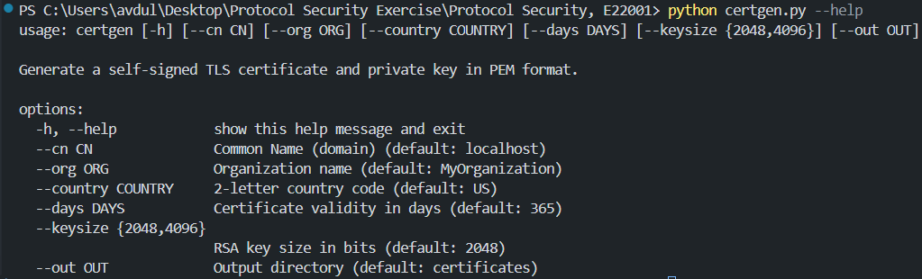
Output files:
- certificates/cert.pem — the digital certificate
- certificates/key.pem — the private key

Certificate Details
Field | Value
Subject | CN=localhost, O=MyOrganization, C=US
Serial | 392460556288010967306490971014920533614006916185
Valid From | 2026-05-13
Valid Until | 2027-05-13
Algorithm | SHA-256 with RSA (2048-bit)
Format | X.509 v3, PEM encoded

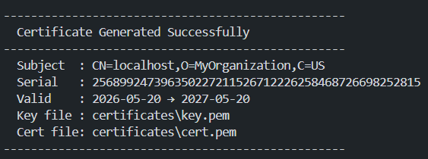

Server Testing
- The certificates were tested using the provided Python server implementation (server.py). The server was started with:
- python server.py
- Upon navigating to https://localhost:4000, the browser displayed the server's directory listing over a secure HTTPS connection, confirming that TLS is functioning correctly.
